MILESTONE 4: TESTING, VALIDATION & SECURITY
- The objective of Phase 4 is to ensure that the developed solution works as expected, meets all functional requirements, and follows basic security and access control best practices.
- This phase validates the end-to-end automation, confirms data accuracy, and ensures that only authorized users can access or modify ticket data.

Data Validation Checks
- Mandatory fields captured correctly.
- Auto-number generated without duplication.
- Category and Subcategory values stored accurately.
- Reference fields resolve correctly to user and group tables.

Activity : 1 Testing & Validation.

Test Scenario 1
- Enter one Caller Name.
- Short Description: WiFi not working in library
- Then Save the Form.
- And Reload the Form.
- Then it fills auto as :
- Category → Network.
- Subcategory → WiFi.
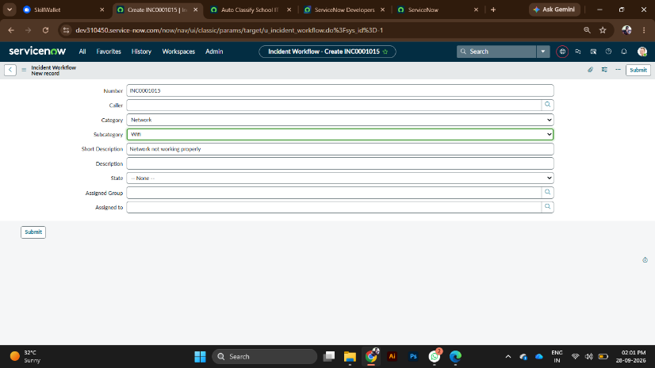
- Email sent to caller Email Id.

Activity : 2 Check Email Notification.
- Open All menus → Search Emails.
- Under System logs → Select Emails.
- Search with the Given Subject Name.
- Open that Record and Under Related Links Click Preview mail Option.
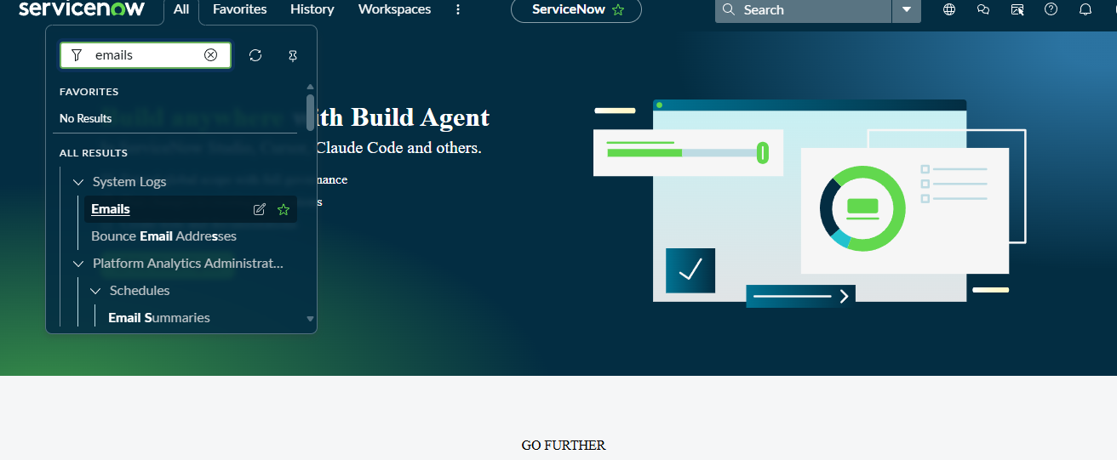
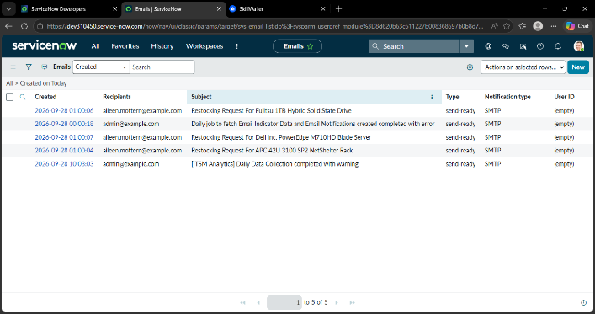
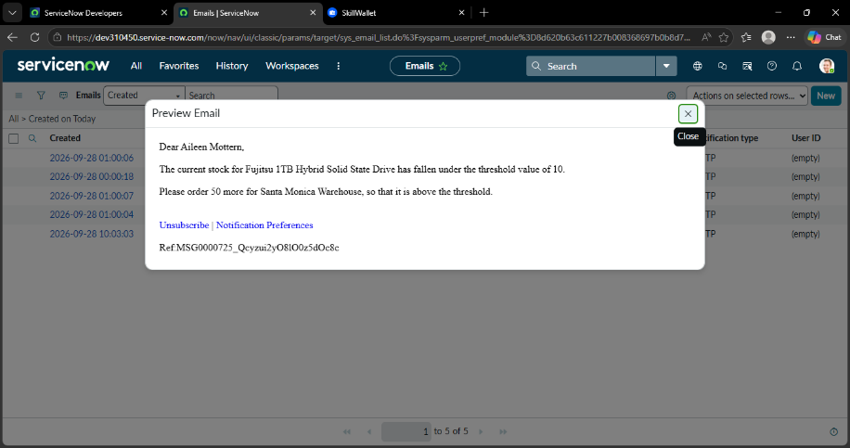

Activity : 3 Test Scenario 2
- Enter one Caller Name.
- Short Description: Projector not turning on.
- Then Save the Form.
- And Reload the Form.
- Then it fills auto as :
- Category → Hardware.
- Subcategory → Projector.
- Then Email sent to caller Mail id.



